Week1

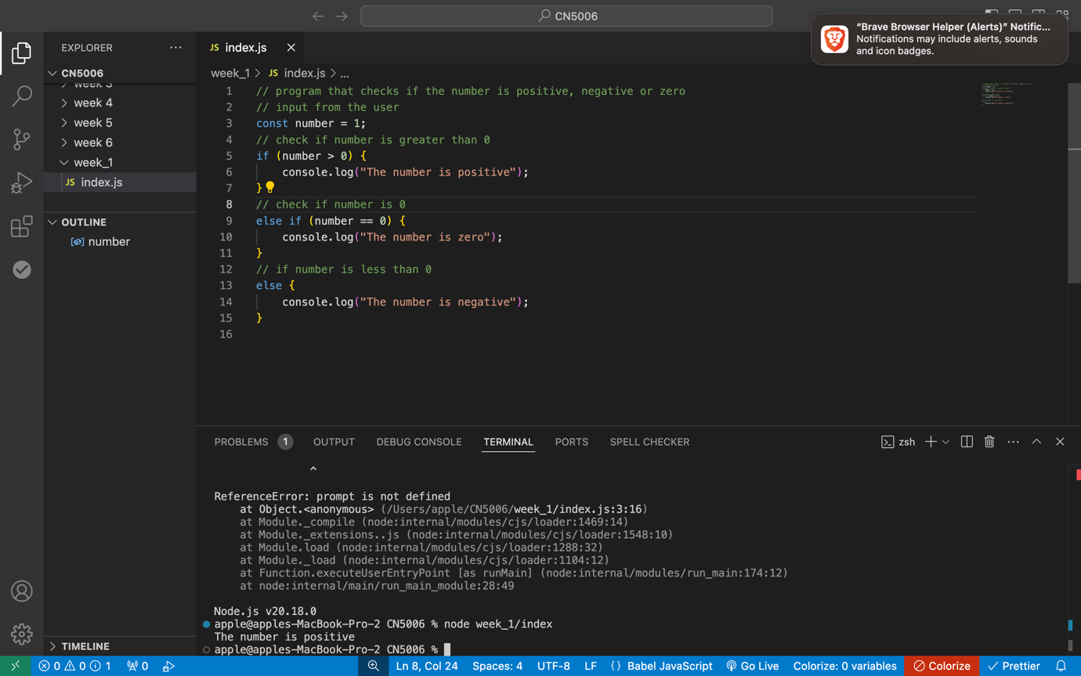

1. **The prompt() function is used to take user input as a string.**
2. **The parseInt () function converts the string input to an integer.**
3. **The if statement checks whether the number is greater than 0.**
4. **The else if statement checks if the number equals 0.**
5. **The else block handles all other cases, meaning the number is less than 0.**

**This program will print a message in the console based on the input given by the user.**